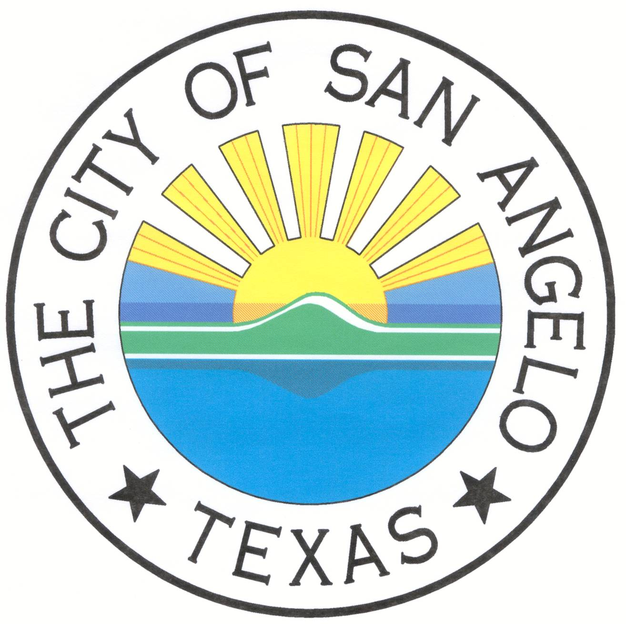**NOTICE OF A PUBLIC MEETING**

**AN AGENDA OF A REGULAR MEETING OF CIVIC EVENTS**

**THE CITY OF SAN ANGELO, TEXAS**

**11:00 A.M. - Thursday, April 26, 2018**

**McNease Convention Center, South Meeting Room**

**501 Rio Concho Drive**

**San Angelo, TX 76903**

**THE MCNEASE CONVENTION CENTER IS ACCESSIBLE TO PERSONS WITH DISABILITIES. ACCESSIBLE ENTRIES AND SPECIALLY MARKED PARKING SPACES ARE AVAILABLE AT BOTH MAIN ENTRANCES AT SURBER DRIVE AND RIO CONCHO DRIVE. IF ADDITIONAL ASSISTANCE IS NEEDED TO OBSERVE OR COMMENT, PLEASE NOTIFY CIVIC EVENTS MANAGER SIDNEY WALKER AT THE CONVENTION CENTER OR AT 653-5328 AT LEAST 24 HOURS PRIOR TO THE MEETING.**

**In an effort to provide our viewing public with information on the various City Boards and Commissions, this meeting will be recorded and broadcasted on Local Government Channel 17 every Thursday at 8am, all month long. For a schedule of all broadcasts, contact the Public Information Office at 481-2727 or visit our Web site at www.cosatx.us.**

***As a courtesy to those in attendance, please place your cell phone on “Silent” or “Vibrate”***

1. **OPEN SESSION (11:00 A.M.)**
   1. **Call to Order**
   2. **Public Comment**

The Board takes public comment on all items in the Regular Agenda. Public input on a Regular Agenda item will be taken at its appropriate discussion. Public input on an item on the Agenda or Consent Agenda may be identified and requested for consideration by the Board at this time. The Board may request an item to be placed on a future agenda, or for a Consent Agenda item, to be moved to the Regular Agenda for public comment.

# CONSENT AGENDA

* + 1. Consideration of approving the Feb 28, 2018 meeting minutes.

# REGULAR AGENDA: PUBLIC HEARING AND COMMENT

2. Presentation of the monthly financial report and event calendar.

3. Discussion of Civic Events Facility Projects and recommending any related matters.

4. Consideration of future agenda items.

5. Adjournment

Given by order of the City Council and posted in accordance with Title 5, Texas Government Code, Chapter 551, Monday, April 23, 2018, at 11:00 A.M.

/s/________________________

Sidney Walker, Civic Events Manager