**Boil Water Notice for Community Public Water Systems**

**February 16, 2021**

Due to multiple breaks of water mains in various areas of San Angelo that resulted in a reduction in water pressure, the Texas Commission on Environmental Quality has required the City of San Angelo public water system (PWS 2260001) to notify all City of San Angelo water customers **(SEE ATTACHED MAP OF AFFECTED AREA)** to boil their water prior to consumption (e.g., washing hands/face, brushing teeth, drinking, etc). Children, seniors, and persons with weakened immune systems are particularly vulnerable to harmful bacteria, and all customers should follow these directions). The PaulAnn area is still under a do-not-consume and the Northern Industrial area is still under a do-not-use order.

To ensure destruction of all harmful bacteria and other microbes, water for drinking, cooking, and ice making should be boiled and cooled prior to use for drinking water or human consumption purposes. The water should be brought to a vigorous rolling boil and then boiled for two minutes.

In lieu of boiling, individuals may purchase bottled water or obtain water from some other suitable source for drinking water or human consumption purposes.

When it is no longer necessary to boil the water, the public water system officials will notify customers that the water is safe for drinking water or human consumption purposes.

Once the boil water notice is no longer in effect, the public water system will issue a notice to customers that rescinds the boil water notice in a manner similar to this notice.

Please share this information with all the other people who drink this water, especially those who may not have received this notice directly (for example, people in apartments, nursing homes, schools, and businesses). You can do this by posting this notice in a public place or distributing copies by hand or mail.

If you have questions concerning this matter, or need assistance in interpreting or translating this notice, you may contact Allison Strube or Andy Vecellio in the office of the Director of Water Utilities at 325-657-4209, 301 W. Beauregard Ave.

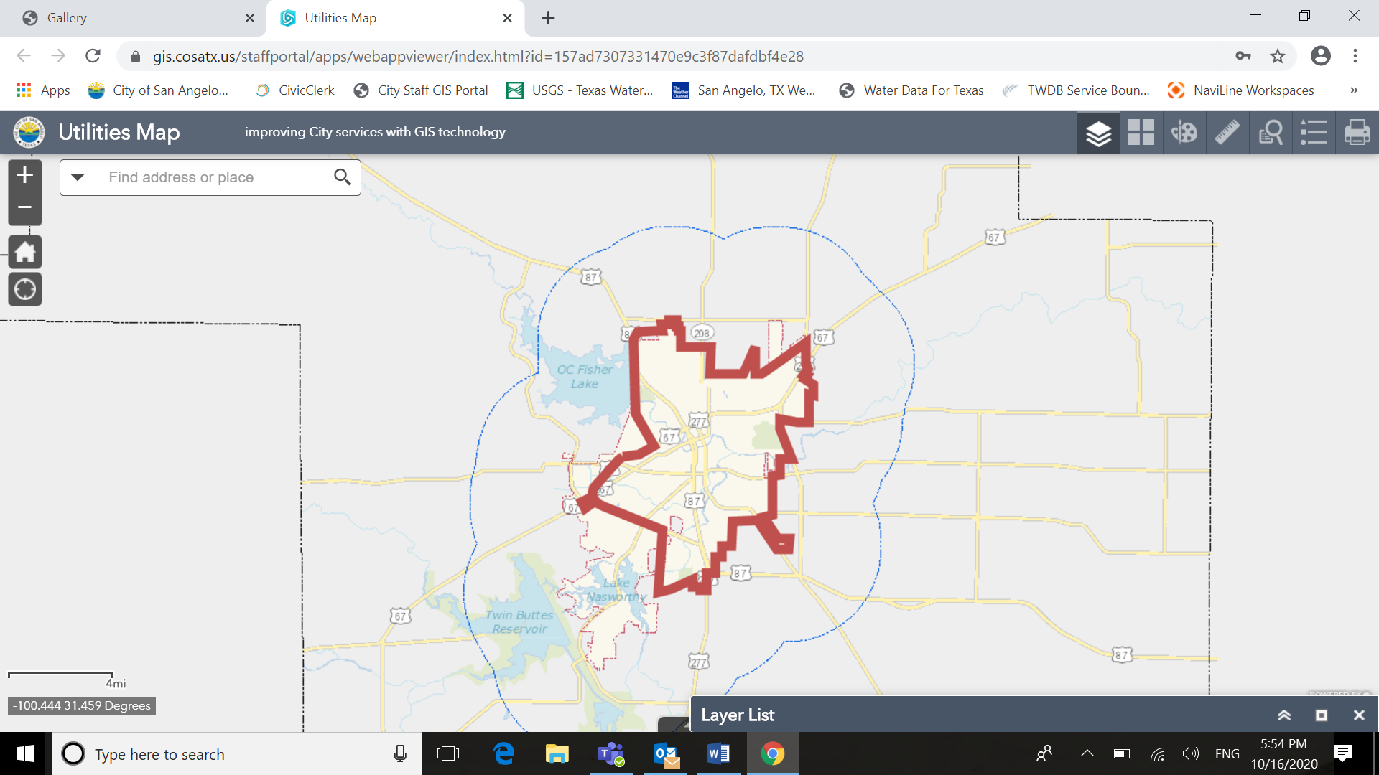

Loop 306

Foster Road

Howard Street

Areas included: All customers inside Loop 306. Customers outside the loop east of Howard Street / O.C. Fisher Dam on the north side of town and those customers outside the loop east of Foster Road on the south side of town