

**Downtown District Overlay Zone Expansion**

What is the Downtown District?

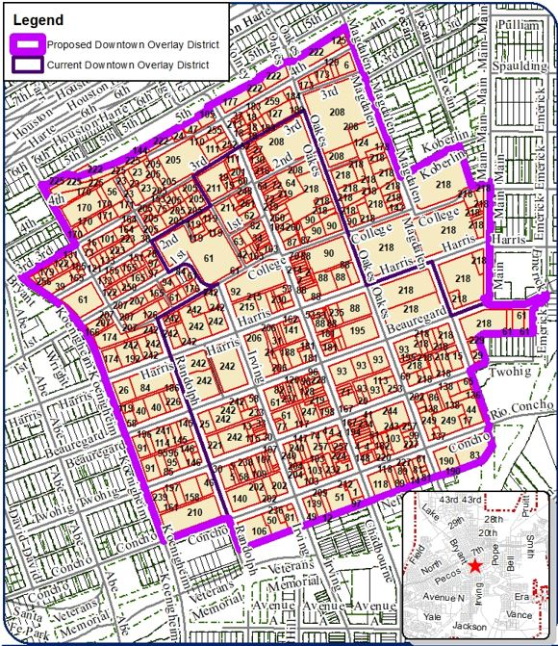

The Downtown District is an overlay zone that allows the City to review new exterior construction projects to ensure quality design standards. For example, businesses or individuals who want to build a new canopy or repaint their building will require approval. The objectives are to protect downtown San Angelo’s historic and cultural character, as well as the area’s attractiveness to visitors.

Why is the Downtown District expanding?

City Council approved the Downtown District overlay zone in Sept. 2019 and has directed staff to evaluate expanding the district to include more properties. The new boundary would expand west from Randolph to Koenigheim, north from 3rd Street to 5th Street, and east from Oakes Street to Main Street. The expansion means more properties will require design approval, in turn protecting the historic and cultural character of downtown, and ensuring compatible development with existing businesses.

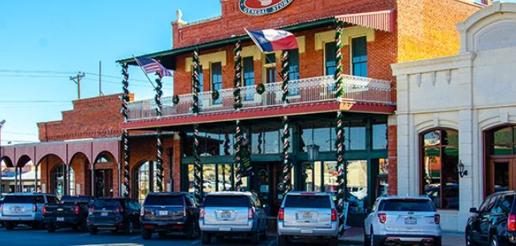

**Please contact the Planning Division at 325-657-4210 or** [**planning@cosatx.us**](mailto:planning@cosatx.us) **for further information.**

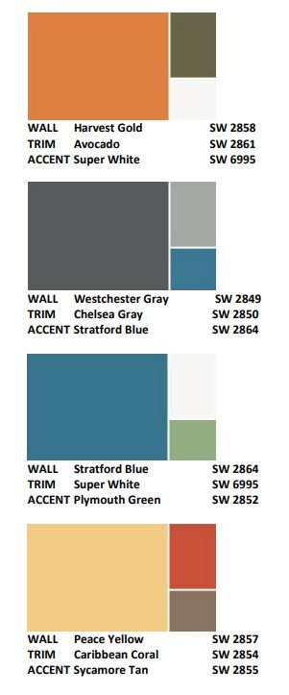

Properties within the Downtown Design District will require an approval for any exterior improvements, including building additions, canopies and awnings, signs, fencing and exterior painting. Certain approvals, such as signs under 50 sq. ft. and exterior painting, may be approved by the planning director. Other approvals require review by the Design and Historic Review Commission (DHRC). City staff and the planning director/DHRC would review the proposed designs, colors and materials to ensure the project is compatible with current standards and City design criteria.

What approvals will I need to build in the future?

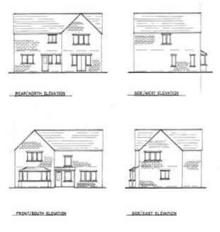

Underlying zoning is not affected by being in the Downtown District. If your property is zoned for a retail store, you are still allowed to build or add onto a retail store. However, any new building, addition to an existing building or other exterior improvements such as a new canopy, awning, structure, sign or repainting the outside would require an approval.

**Further questions?**

**Please call the Planning Division or set up a pre-development meeting with Development Services at 325-657-4210.**

Will this affect my zoning?

What I can do with my property?

**Please contact the Planning Division at 325-657-4210 or** [**planning@cosatx.us**](mailto:planning@cosatx.us) **for further information.**